AMBABA COMMERCE COLLEGE, MANIBA INSTITUTE OF BUSINESS MANAGEMENT &
DEVIBA INSTITUTE OF COMPUTER APPLICATION , SABARGAM.

VEER NARMAD SOUTH GUJARAT UNIVERSITY, SURAT



PROJECT REPORT
ON
CITY-WISE AIR QUALITY INDEX (AQI)
AND AIR POLLUTION ANALYSIS

SUBMITTED BY: GUIDED BY:
Bhayani Venish M.(263) Ms.Krishna Trivedi
Sodvadiya Nil V. (324)


AMBABA COMMERCE COLLEGE,MANIBA
INSTITUTE OF BUSINESS MANAGEMENT &
DEVIBA INSTITUTE OF COMPUTER APPLICATION, SABARGAM (Self Finance)
At. Sabargam, Po.Niyol, Tal. Choryasi, Surat-394 325.
Managed By Shree Dakshin Gujarat Shikshan Samaj, Kumbharia

Certificate

This is to certify that Bhayani Venish M. Class Ty BCA Div:-4
Roll Number: 263 Exam Seat Number: 3130
have/has satisfactorily presented their Project work Entitled City-Wise Air Quality Index (AQI) Data Analytics using Python as a partial fulfilment of requirements for 6th Semester– B.C.A., during the academic Year 2025-2026.

Guide Name:- Krishna Trivedi

Dr. Falguni M Thakkar
Principal
Ambaba Commerce College, MIBM & Deviba
Institute of Computer Application, Sabargam

Date : 16/03/2026
Place : Sabargam, Surat
AMBABA COMMERCE COLLEGE,MANIBA
INSTITUTE OF BUSINESS MANAGEMENT &

DEVIBA INSTITUTE OF COMPUTER APPLICATION, SABARGAM (Self Finance)
At. Sabargam, Po.Niyol, Tal. Choryasi, Surat-394 325.
Managed By Shree Dakshin Gujarat Shikshan Samaj, Kumbharia

Certificate

This is to certify that Sodvadiya Nil V.. Class Ty BCA Div:-4
Roll Number: 324 Exam Seat Number: 3367
have/has satisfactorily presented their Project work Entitled City-Wise Air Quality Index (AQI) Data Analytics using Python as a partial fulfilment of requirements for 6th Semester– B.C.A., during the academic Year 2025-2026.

Guide Name:-Krishna Trivedi

Dr. Falguni M Thakkar
Principal
Ambaba Commerce College, MIBM & Deviba
Institute of Computer Application, Sabargam

Date : 16/03/2026
Place : Sabargam, Surat

Declaration

I here by declare that the project report entitled " City-wise Air Quality Index (AQI) and Air Pollution Analysis ", submitted by me to ambaba commerce college,maniba institude of business management & deviba institude,sabargam of computer application is a record of my original work.

This project has been completed under the valuable guidance of ms.krishna Trivedi.I further declare that this work has not been submitted to any other institution or university for any purpose.

Acknowledgement

It gives me immense pleasure to express my sincere gratitude to all those who have contributed directly or indirectly to the successful completion of this project report.

I am highly indebted to my guide, ms.krishna Trivedi, for her valuable guidance, continuous encouragement, and constructive suggestions throughout the development of this project.

I am also thankful to all the faculty members of ambaba commerce college,maniba institude of business management & deviba institude,sabargam of computer application , for providing the necessary facilities and support.

Finally, I would like to express my heartfelt thanks to everyone who helped me during this project.

INDEX
No | Content | Page No
1. | Introduction  1.1 Project Profile  1.2 Overview of the Project  1, 3 0biectives of the System  1.4 Problem Statement  1.5 Features of the proposed System
2. | Hardware & Software Specifications
3. | Dataset Description  3.1. Dataset Overview  3.2. Characteristics of the Dataset  3.3. Purpose of the Dataset  3.4. Significance  3.5. Dataset
4. | Methodology
5. | Data Cleaning
6. | Exploratory Data Analysis (EDA)  6.1 Univariate analysis  - 2 Bivariate analysis  - Multivariate analysis  Skewness and Kurtosis
7. | Regression Analysis
8. | Visualisation and Interpretation
9. | Summery
10 | Conclusion  Limitation  Future Enhancements
11. | References

1.Introduction

  - Project Profile
Category | Details
Project Title | CITY-WISE AIR QUALITY INDEX (AQI) AND AIR POLLUTION ANALYSIS
Domain / Area | Data Analytics, Environmental Data Analysis and Air Quality Monitoring, Regression, Supervised Learning
Programming Language | Python
Frontend (Visualization) | Matplotlib, Plotting,seaborn
Backend  (Processing  Engine) | Python (NumPy, Pandas,)
Tools / IDE Used | Jupyter notebook
Database/  Storage | File-Based Storage System (CSV Dataset)
Libraries Used | Pandas, NumPy, Matplotlib, Seaborn
Documentation  Tool | MS Word / PDF
Platform Windows | Windows
Internal Guide | Ms.krishna trivedi
Submitted To | ambaba commerce college,maniba institude of business management  & deviba institude,sabargam of computer application
Academic Year | 2025-26

1.2 Overview of the Project

This project analyses and compares the Air Quality Index (AQI) levels of different cities to understand the severity of air pollution and its impact on the environment and public health.
The dataset contains city-wise air quality information along with major air pollutants such as PM2.5, PM10, NO₂, SO₂, CO, and O₃.
Using Python, the project performs:
• data cleaning and preprocessing
• descriptive statistical analysis
• pollutant-wise analysis
• AQI category distribution analysis
• correlation analysis between pollutants and AQI
• visualisations showing city-wise air quality trends
The goal of this project is to identify highly polluted cities, determine dominant pollutants, and understand how different pollutants influence AQI levels. This analysis provides clear insights into air pollution patterns and supports data-driven environmental awareness and decision-making.

1.3 Objective of the System

• To compare Air Quality Index (AQI) levels across different cities.
• To clean and preprocess air quality datasets by handling missing values and incorrect entries.
• To calculate important statistical measures such as mean, median, mode, standard deviation, and variance for AQI and pollutant data.
• To analyze how each air pollutant (PM2.5, PM10, NO₂, SO₂, CO, and O₃) impacts overall AQI levels.
• To study the distribution of AQI categories such as Good, Moderate, Poor, and Severe.
• To visualize air quality trends using bar charts, line graphs, heatmaps, and other plots.
• To identify highly polluted cities and dominant pollutants affecting air quality.
• To present air pollution insights in a simple, analytical, and easy-to-understand manner.

1.4 Problem Statement

Air pollution levels vary significantly across different cities, but raw air quality data alone does not clearly explain pollution severity or its impact on the environment and public health. Without proper analysis, it becomes difficult to understand:
• how AQI levels differ between cities,
• which pollutants contribute most to poor air quality,
• how pollution patterns change across locations, and
• which cities are most affected by air pollution.
Manual analysis of large air quality datasets containing hundreds of records and multiple pollutant parameters is time-consuming, error-prone, and difficult to interpret. This makes it challenging to draw accurate conclusions from the data.
Therefore, a Python-based analytical system is required to:
• clean and preprocess city-wise AQI and pollutant data,
• calculate meaningful statistical measures,
• analyze the impact of individual pollutants on AQI,
• visualize air quality trends and AQI categories, and
• clearly compare pollution levels across different cities.
This system helps in making accurate, data-driven conclusions about air pollution severity, dominant pollutants, and overall air quality conditions, supporting better environmental understanding and awareness.

1.5 Features of the Proposed System

• Imports and analyses city-wise AQI and pollutant datasets.
• Automatically handles missing values and inconsistent data.
• Calculates statistical measures such as mean, median, mode, variance, and standard deviation for AQI and pollutants.
• Performs pollutant-wise and AQI category analysis to study relationships between different pollutants and air quality.
• Visualises results using bar charts, line graphs, heatmaps, and scatter plots.
• Compares air quality levels, pollution severity, and dominant pollutants across multiple cities.
• Displays clear insights on pollution trends, high-risk cities, and key contributing pollutants.
• Easy to use and suitable for environmental researchers, policymakers, and students studying air pollution patterns.

2.Hardware & Software Specification

2.1 Features of the Proposed System
Component | Description
Processor | Intel Core i5 or AMD equivalent (Minimum 2.0 GHz)
RAM | Minimum 4 GB (8 GB recommended for faster data processing
Storage | At least 500 MB of free space for datasets, Python installation, libraries, and the project files.
Graphics | Basic graphics support (Matplotlib visualisation compatible)
Input Devices | Keyboard, Mouse
Output  Devices | Monitor with a minimum 720p resolution

2.2 Features of the Proposed System
Software | Description
Operating System | Windows 11
Programming  Language | Python
IDE / Text Editor | IDLE (jupyter notebook)
Python Libraries | pandas, numpy, matplotlib,seaborn
Data Visualization  Tools | Matplotlib(built-in plots)

3.Dataset Description

3.1 Dataset Overview

The dataset used in this project contains city-wise Air Quality Index (AQI) records along with the concentrations of major air pollutants such as PM2.5, PM10, NO₂, SO₂, CO, and O₃. Each record includes the city name, AQI value, and AQI category, providing a complete overview of air quality levels across different cities. The dataset may also contain missing values, inconsistent entries, or outliers, reflecting real-world challenges in environmental data collection. This allows the project to demonstrate data preprocessing, cleaning, and analysis techniques using Python to ensure accurate and reliable results.

Attribute | Description | Type
CityID | Unique identifier for each city | Numeric
CityName | Name of the city | Categorical
AQI | Air Quality Index value | Numeric
AQI_Category | Category of air quality (Good, Moderate, Poor, Severe) | Categorical
PM2.5 | Concentration of PM2.5 particles (µg/m³) | Numeric
PM10 | Concentration of PM10 particles (µg/m³) | Numeric
NO2 | Concentration of Nitrogen Dioxide (µg/m³) | Numeric
SO2 | Concentration of Sulfur Dioxide (µg/m³) | Numeric
CO | Concentration of Carbon Monoxide (mg/m³) | Numeric
O3 | Concentration of Ozone (µg/m³) | Numeric
MeasurementDate | Date of air quality measurement | Date

3.2 Characteristics of the Dataset
• The dataset contains records for multiple cities, capturing their air pollutant concentrations and corresponding AQI values for detailed analysis and comparison.
• It includes a combination of numeric, categorical, and derived attributes, such as pollutant concentrations (PM2.5, PM10, NO2, SO2, CO, O3), AQI values, and AQI categories.
• Certain fields may include missing values (e.g., pollutant measurements or AQI for specific dates) to simulate real-world environmental data inconsistencies.
• The dataset contains both air quality indicators (PM2.5, PM10, NO2, SO2, CO, O3, AQI) and city attributes (City name, State/Region).
• The AQI attribute is a derived field, calculated by aggregating all individual pollutant concentrations according to standard AQI calculation methods.
• The dataset does not contain duplicate city-date records; however, minor variations or inconsistencies may exist due to measurement errors or reporting differences.
• Data spans multiple cities, pollutant types, and AQI categories, making the dataset suitable for comparative analysis of air quality across cities, trend analysis over time, and health impact assessments.

3.3 Purpose of the Dataset

• To demonstrate data preprocessing and cleaning techniques, including handling missing pollutant values, encoding categorical attributes such as AQI categories, and normalizing numeric pollutant concentration data.
• To serve as a practical dataset for Exploratory Data Analysis (EDA), allowing analysts to examine pollutant distributions, AQI trends, and correlations between different pollutants and overall air quality.
• To support data visualization practice, such as plotting city-wise AQI, category-wise pollution comparisons, pollutant trends over time, and correlation heatmaps among pollutants.
• To enable predictive modeling and machine learning, including regression models for predicting AQI based on pollutant levels and classification models for identifying cities at risk of poor air quality.
• To provide learners with a real-world environmental data context, making the study of data analysis, visualization, and predictive modeling more intuitive and engaging.
• To evaluate air quality variations across different cities, regions, and time periods, using measurable environmental indicators for actionable insights in public health and urban planning.

3.4 Significance
- Helps learners understand real-world environmental monitoring and air quality assessment, a critical and practical application of data analysis.
- Offers a balanced combination of numerical and categorical attributes (pollutant concentrations, AQI values, AQI categories, city names), making it suitable for demonstrating descriptive and predictive data analysis techniques.
- Enables meaningful insights into city-wise pollution levels, AQI trends, and pollutant contributions across different regions.
- Supports deeper analysis of pollutant interactions and correlations, such as PM2.5 vs. PM10, NO2 vs. CO, and pollutant contribution to overall AQI.
- Useful for air quality classification and prediction models, helping identify cities as having Good, Moderate, Poor, or Severe air quality based on data-driven analysis.
- Encourages learners to apply theoretical concepts of data preprocessing, feature engineering, visualization, and predictive modeling on a realistic and actionable environmental dataset.

3.5 Dataset

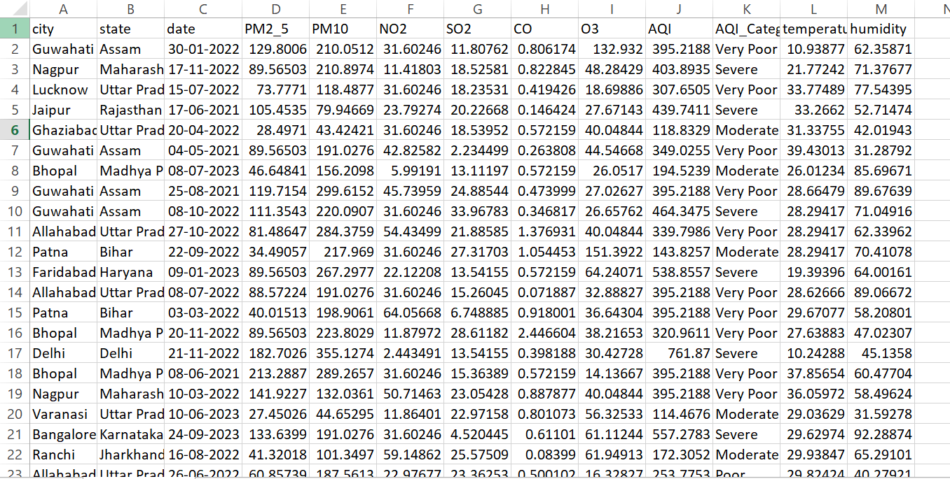

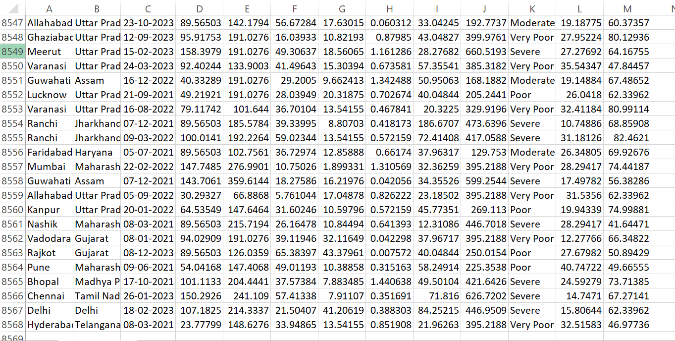

4. Methodology

The methodology of this project explains the systematic process used to analyze and interpret the Air Quality Index (AQI) data of different cities using Python and data analytics techniques.
The project begins with data collection, where the AQI dataset containing city-wise air quality information and pollutant concentrations such as PM2.5, PM10, NO₂, SO₂, CO, and O₃ is obtained in CSV format.
After collecting the dataset, data preprocessing and cleaning are performed to improve data quality. This step includes handling missing values, correcting inconsistent entries, and converting data into the appropriate format. These preprocessing steps ensure that the dataset is reliable and suitable for analysis.
Once the dataset is cleaned, Exploratory Data Analysis (EDA) is conducted to understand the distribution and relationships between different air pollutants and AQI values. Various statistical techniques and visualizations such as histograms, bar charts, scatter plots, and heatmaps are used to explore patterns and trends in the dataset.
Following the exploratory analysis, statistical measures such as mean, median, standard deviation, and variance are calculated to summarize the characteristics of AQI and pollutant data.
Next, regression analysis is applied to examine the relationship between pollutant concentrations and AQI values. This helps in understanding how different pollutants influence air quality levels across cities.
Finally, data visualization and interpretation are performed to present the results in a clear and understandable manner. Graphs and charts help highlight pollution patterns, compare AQI levels among cities, and identify dominant pollutants affecting air quality.
This methodology ensures a structured and analytical approach for studying air pollution data and deriving meaningful insights using Python-based data analytics techniques.

5.Data Cleaning

- Code

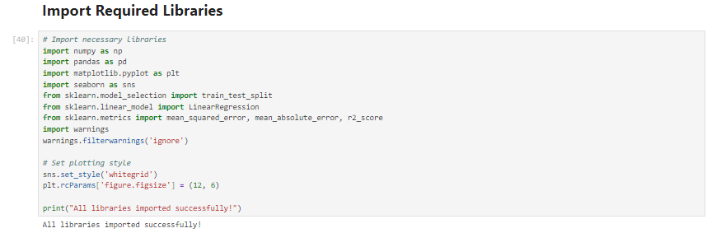
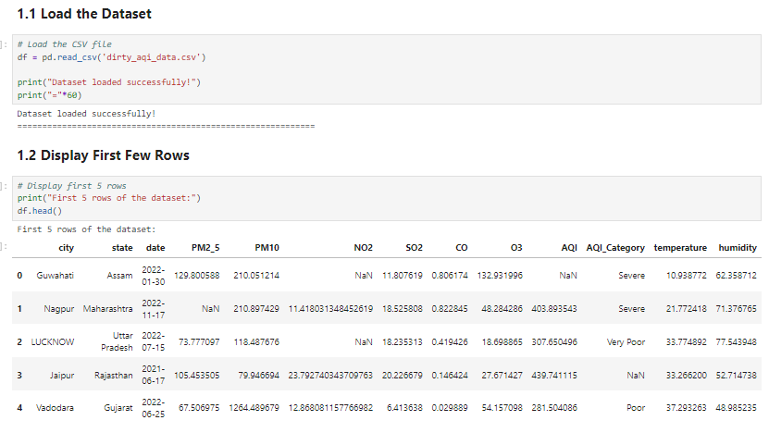
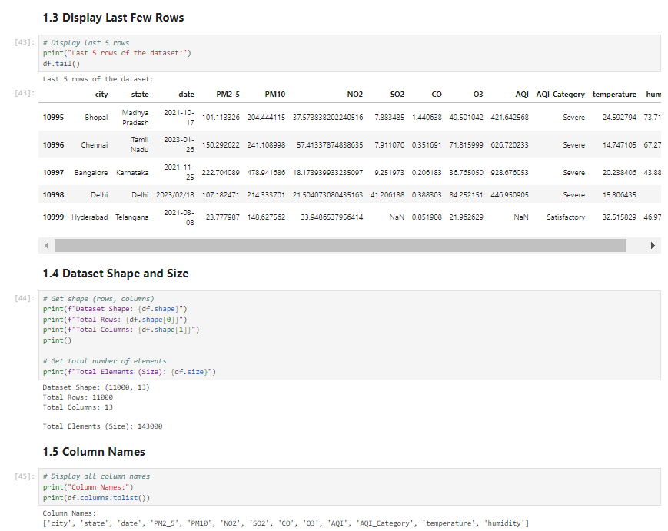
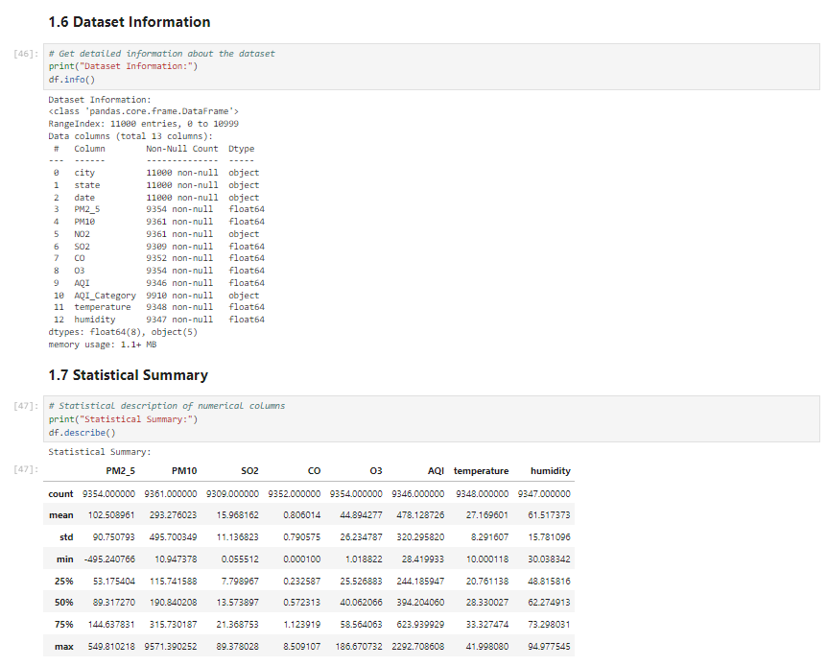
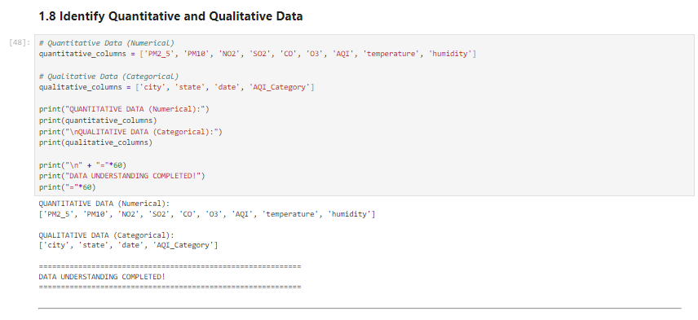
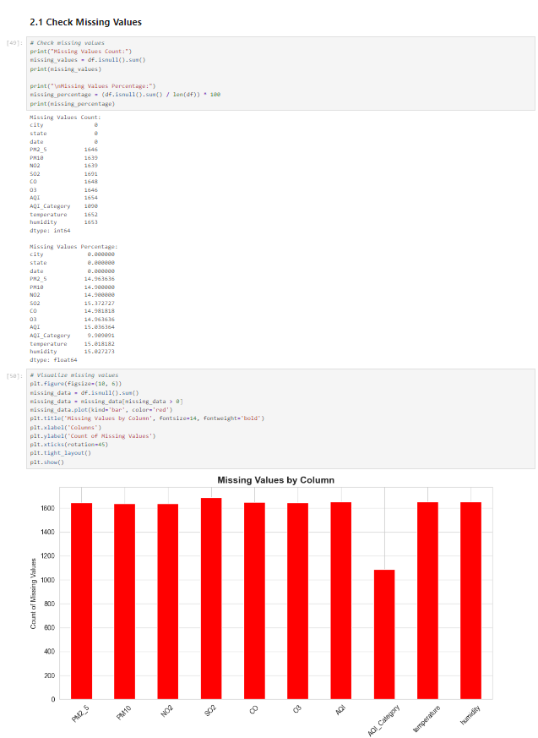
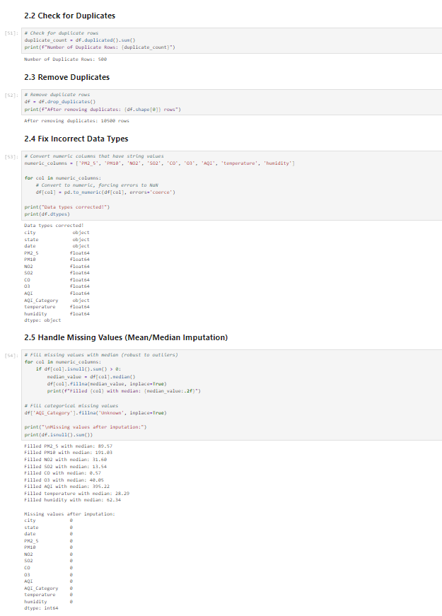
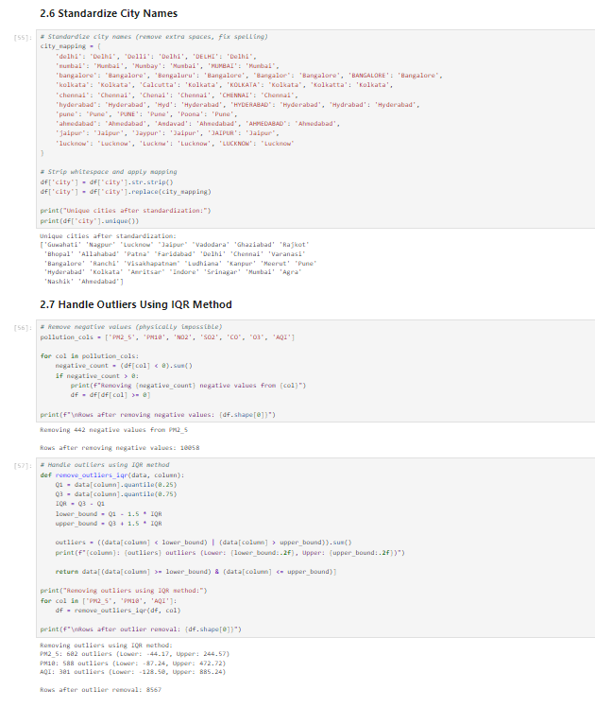
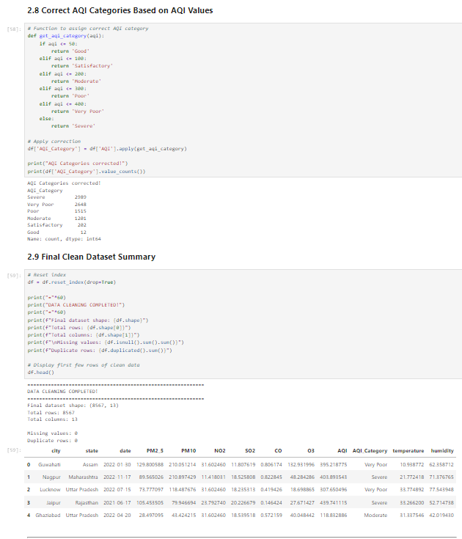

6. Exploratory Data Analysis (EDA)
  - Univariate analysis :
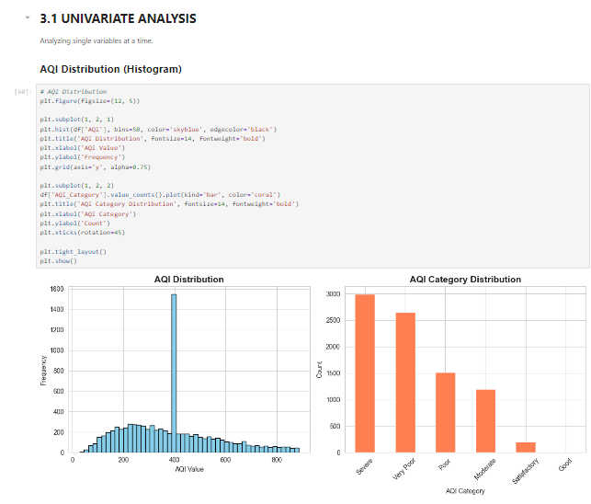
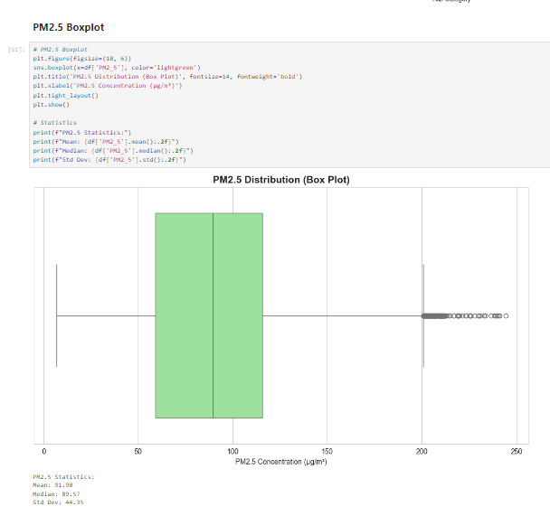
6.2 Bivariate analysis

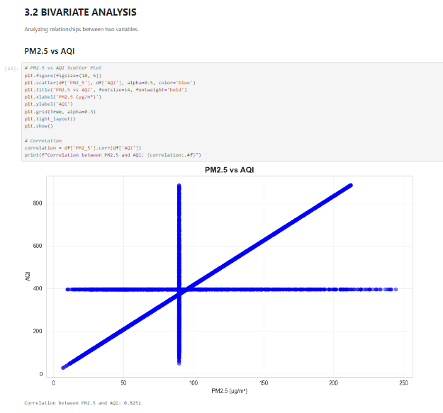
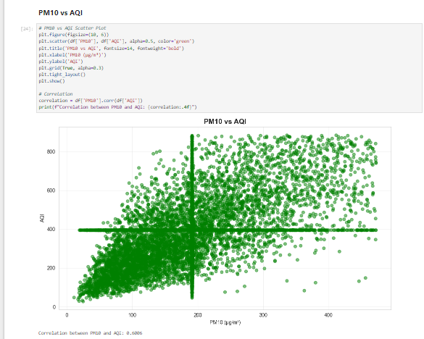

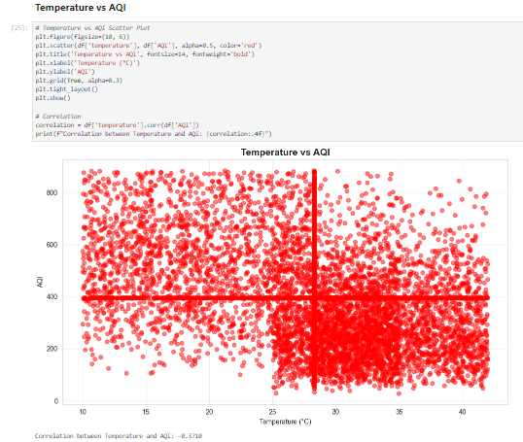
6.3Multivariate analysis

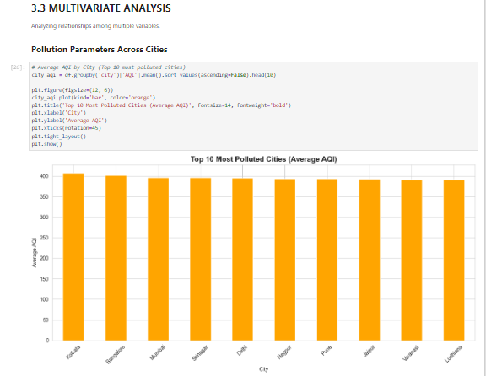
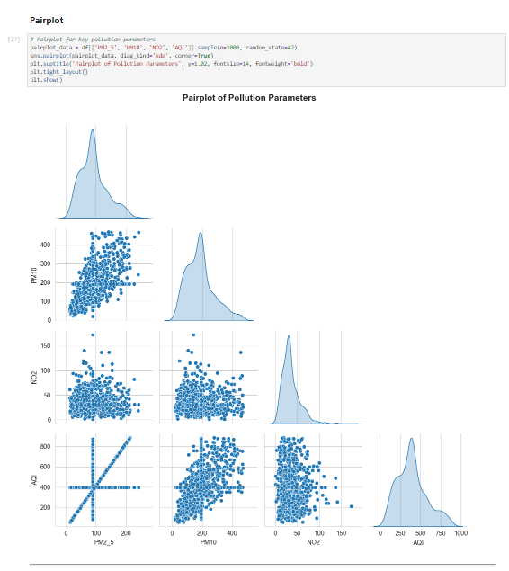
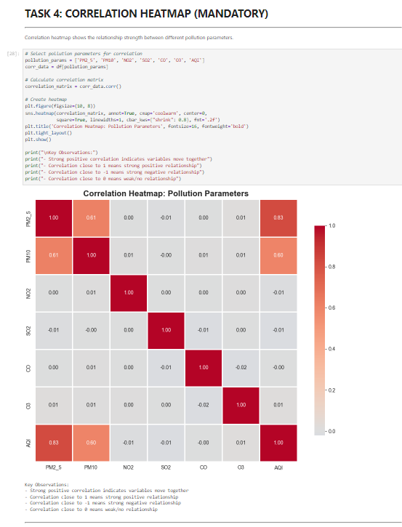

7. Regression Analysis
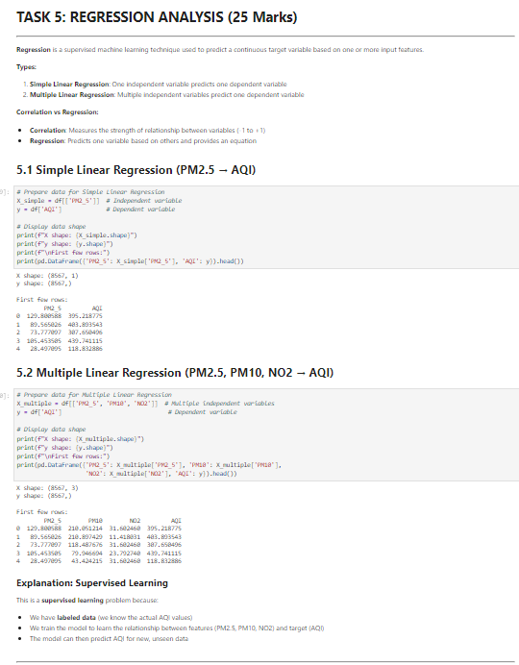
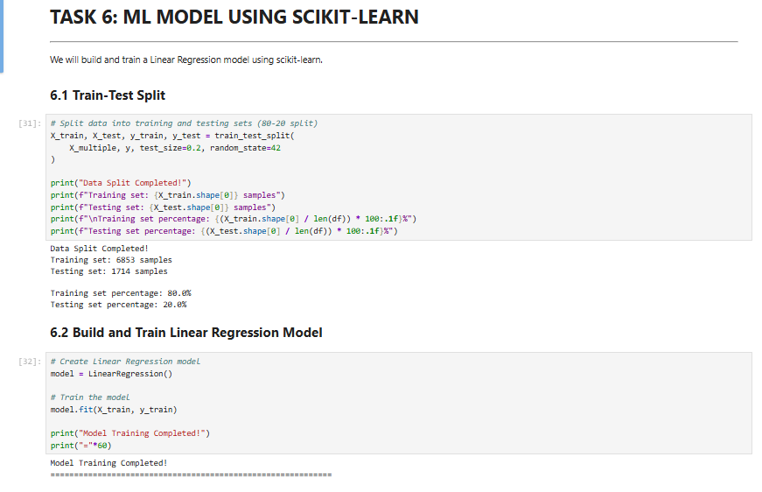
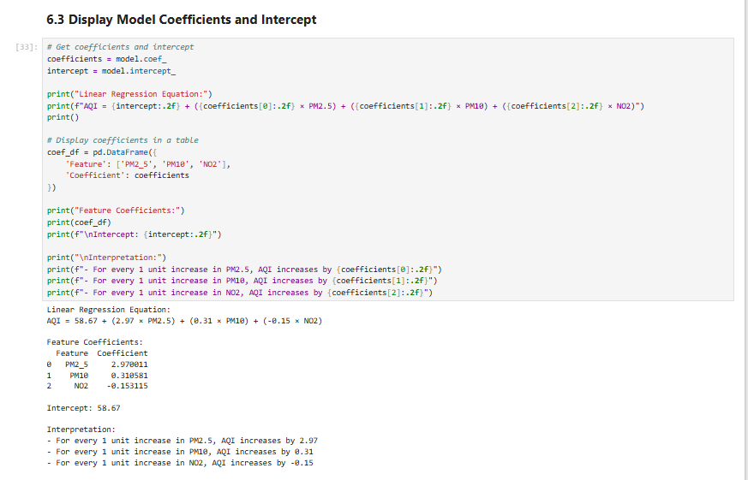
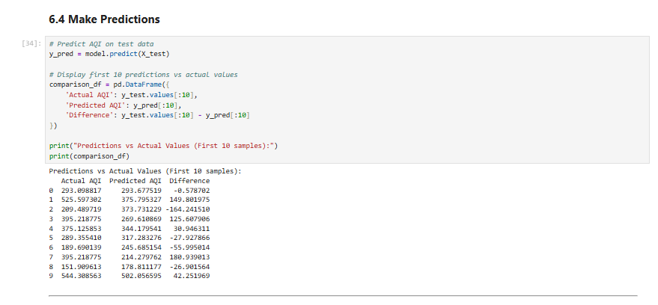
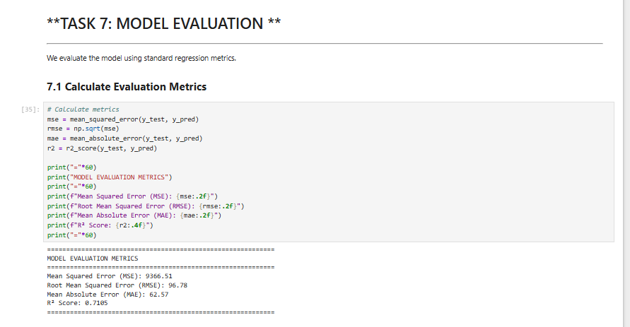
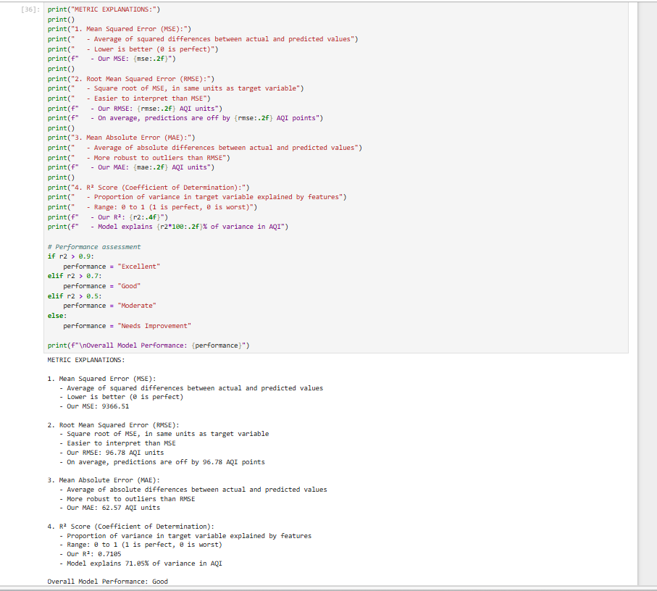
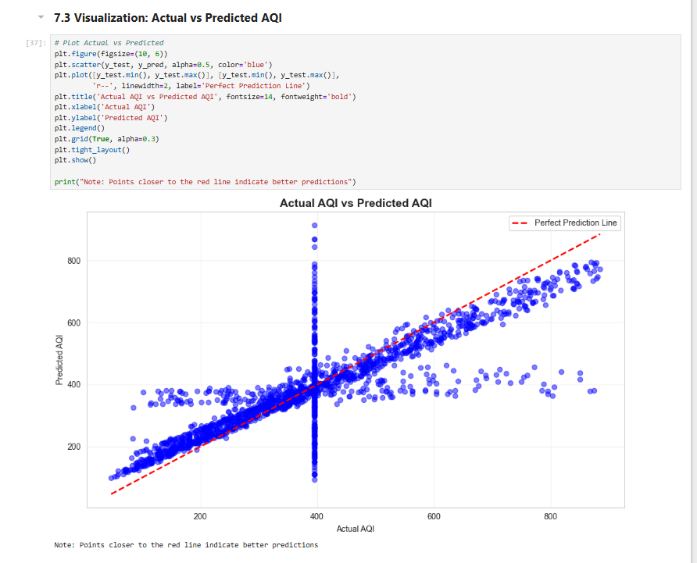
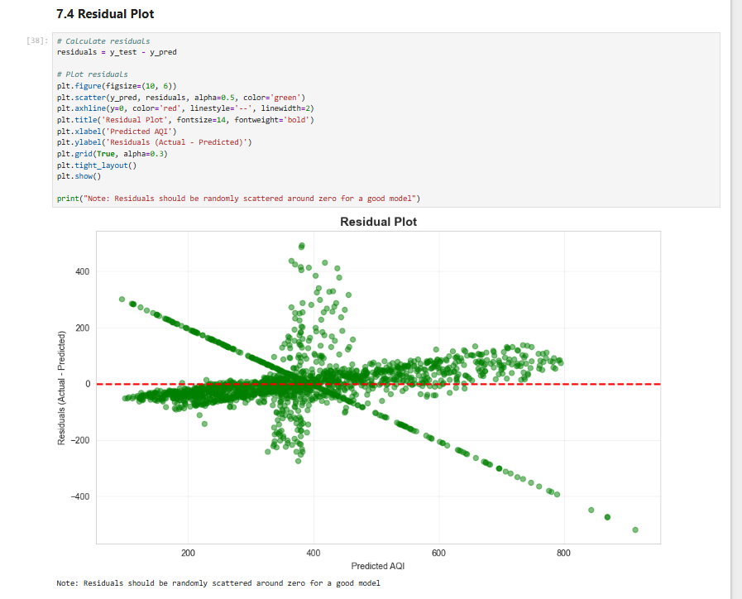
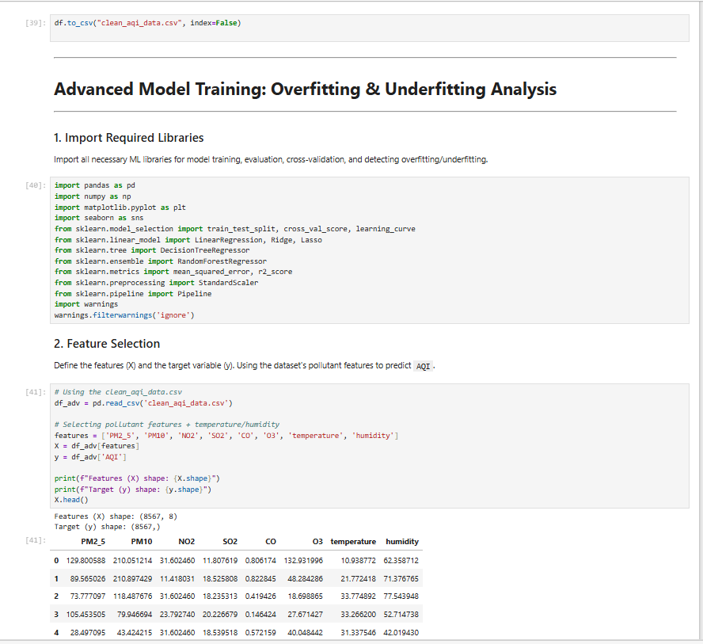
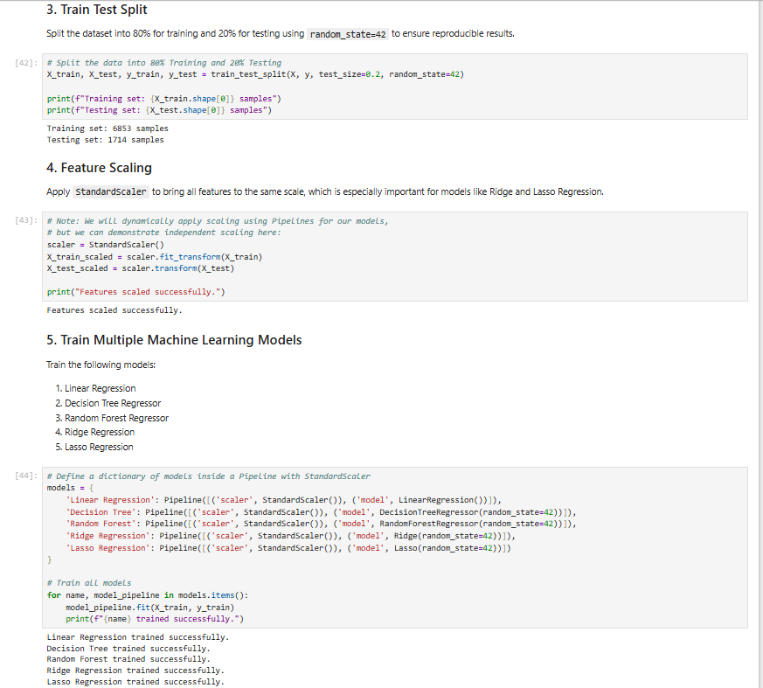
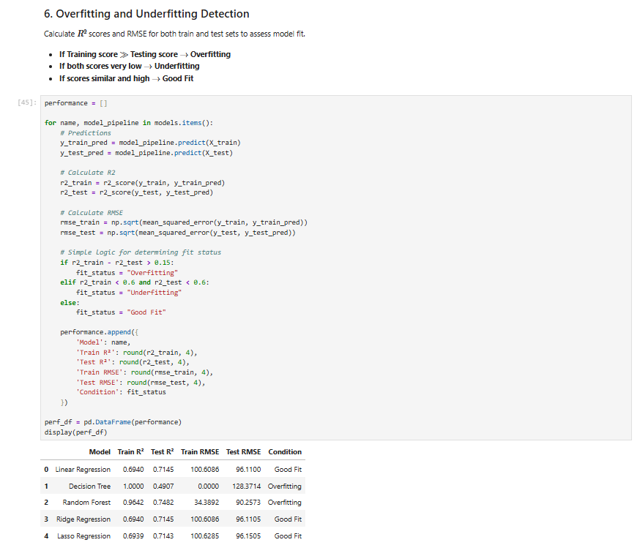
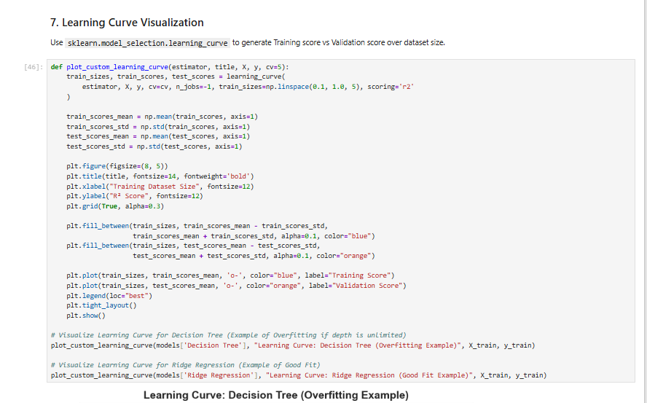
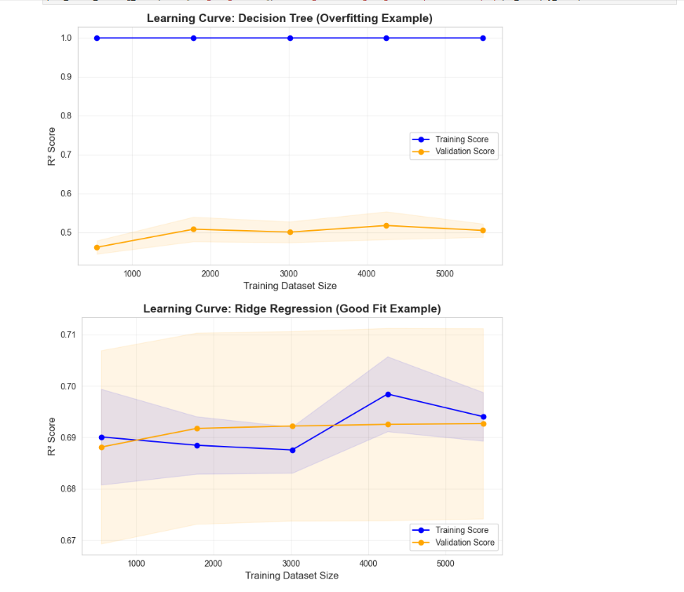
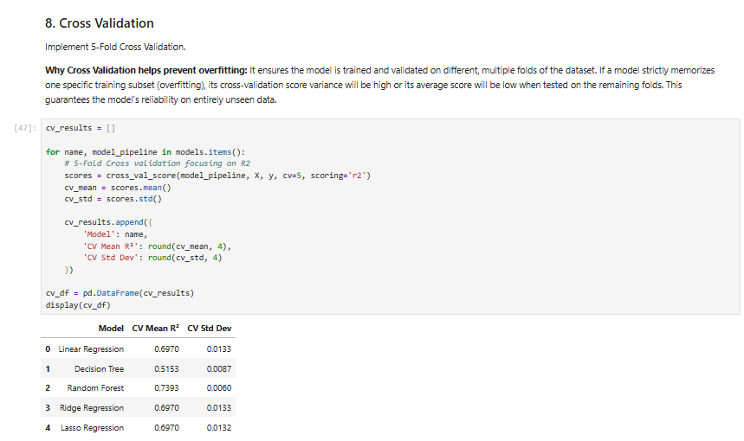
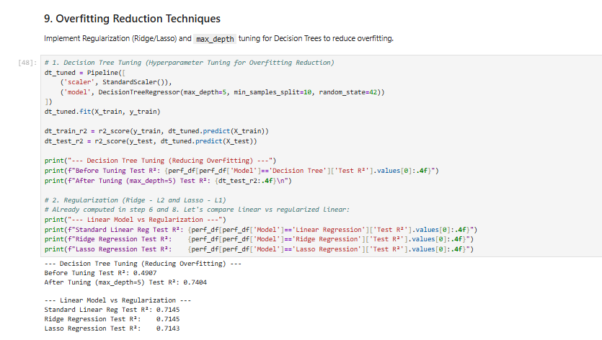
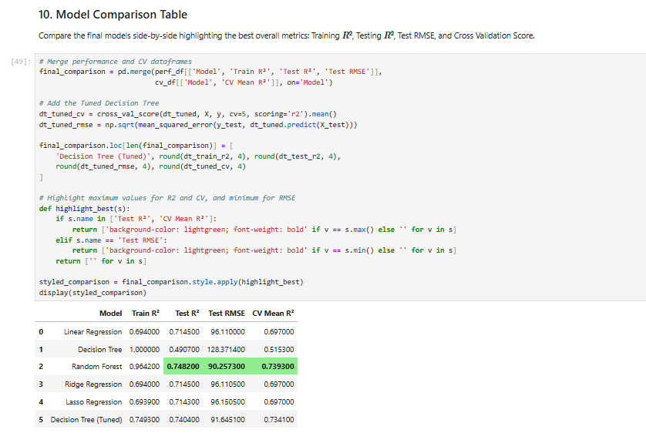
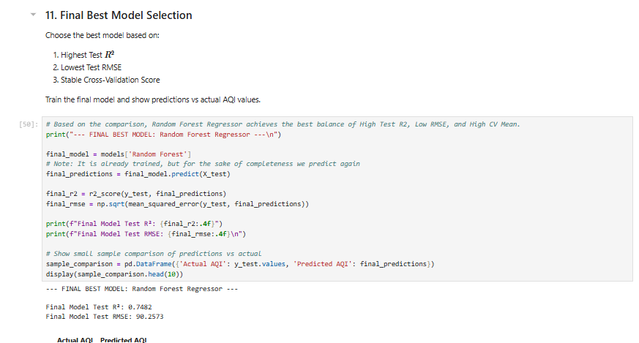
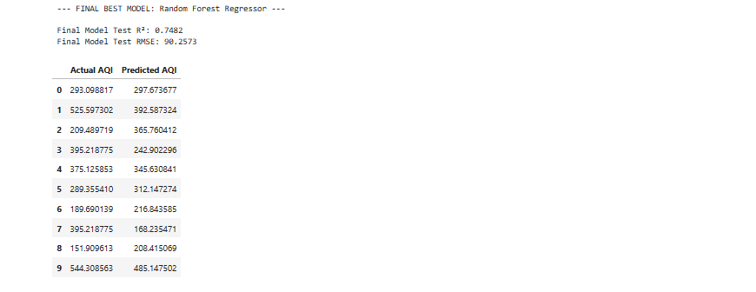
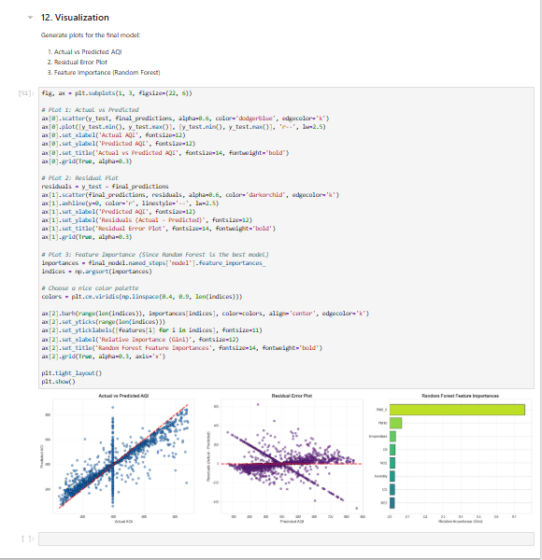

8. Visualization and Interpretation

Visualization
Data visualization is an important part of data analytics because it helps transform complex numerical data into easy-to-understand graphical representations. In this project, different visualization techniques are used to analyze and interpret the Air Quality Index (AQI) and the concentration of various pollutants across different cities.
Using Python libraries such as Matplotlib and Seaborn, several graphs were created to study the relationship between air pollutants and AQI values.
The following visualizations were used in this project:
• Histogram to analyze the distribution of AQI values
• Bar charts to compare AQI levels across different cities
• Scatter plots to examine relationships between pollutants and AQI
• Heatmap to analyze correlation between pollutants
• Pie charts to show AQI category distribution
These visualizations help in understanding pollution trends, identifying highly polluted cities, and studying the impact of pollutants on overall air quality.

Histogram Interpretation (AQI Distribution)
The histogram shows the distribution of AQI values across different cities.
Observations:
• Most AQI values fall in the Moderate and Poor categories
• Only a small number of cities have Good air quality
• A few cities show very high AQI levels, indicating severe pollution
Interpretation:
This indicates that air pollution is a significant issue in many cities, with only a limited number of locations maintaining healthy air quality levels.

Bar Chart Interpretation (City-wise AQI Comparison)
The bar chart compares AQI values across different cities.
Observations:
• Some cities show significantly higher AQI values
• A few cities maintain relatively lower AQI levels
Interpretation:
The bar chart clearly identifies high-pollution cities and allows easy comparison of air quality levels across different locations.

Scatter Plot Interpretation (Pollutants vs AQI)
Scatter plots are used to analyze the relationship between pollutant concentrations and AQI values.
Observations:
• Higher PM2.5 and PM10 concentrations generally lead to higher AQI values
• Some pollutants show stronger relationships with AQI compared to others
Interpretation:
This indicates that particulate matter pollutants such as PM2.5 and PM10 play a major role in determining overall air quality.

Heatmap Interpretation (Correlation Matrix)
A heatmap is used to visualize the correlation between different pollutants and AQI.
Observations:
• PM2.5 and PM10 show strong positive correlation with AQI
• Some pollutants show moderate relationships with AQI
Interpretation:
The heatmap helps identify which pollutants contribute most to air pollution and AQI variation.

Pie Chart Interpretation (AQI Category Distribution)
The pie chart shows the percentage distribution of AQI categories.
Observations:
• Most cities fall under Moderate or Poor AQI categories
• Only a small portion falls under Good air quality
Interpretation:
This visualization highlights the overall air quality condition and shows that a significant number of cities are affected by pollution.

Final Result of Visualization
The visualizations clearly show pollution trends, pollutant relationships, and city-wise AQI variations. These graphical insights help in understanding environmental pollution patterns and support data-driven analysis of air quality.

9. Summary

CITY-WISE AIR QUALITY INDEX (AQI) AND AIR POLLUTION ANALYSIS
The project “City-Wise Air Quality Index (AQI) and Air Pollution Analysis” focuses on analyzing and comparing air pollution levels across different cities using Python-based data analytics techniques. The analysis is performed on an environmental dataset containing air pollutant concentrations such as PM2.5, PM10, NO₂, SO₂, CO, and O₃, along with corresponding AQI values and AQI categories.
The project begins with data collection and preprocessing, where the raw dataset is cleaned to ensure data quality. This includes handling missing values, correcting data types, and removing inconsistent records. These preprocessing steps ensure that the dataset is accurate, consistent, and suitable for further analysis.
After data cleaning, Exploratory Data Analysis (EDA) is carried out to discover patterns and relationships within the dataset.
• Univariate analysis is used to study the distribution of individual variables such as AQI and pollutant concentrations.
• Bivariate analysis examines the relationship between pollutants and AQI using scatter plots and correlation analysis.
• Multivariate analysis explores interactions among multiple pollutants and their combined impact on AQI levels.
The project also applies statistical measures such as mean, median, standard deviation, and variance to better understand the characteristics of the air quality data.
To enhance analytical capability, a Linear Regression machine learning model is implemented using the Scikit-Learn library. The model is trained to study the relationship between pollutant concentrations and AQI values, demonstrating how air pollution levels influence overall air quality.
Various data visualization techniques such as histograms, bar charts, scatter plots, and heatmaps are used to present the results clearly. These visualizations help identify pollution trends, compare air quality levels across cities, and highlight dominant pollutants affecting AQI.
Overall, the project demonstrates how Python and data analytics tools (Pandas, NumPy, Matplotlib, Seaborn, and Scikit-Learn) can be effectively used to analyze environmental data and generate meaningful insights about air pollution patterns.
The analysis provides valuable understanding of city-wise air quality conditions and emphasizes the importance of data-driven approaches for environmental monitoring and pollution awareness.

10. Conclusion

The project “CITY-WISE AIR QUALITY INDEX (AQI) AND AIR POLLUTION ANALYSIS” successfully demonstrates how Python-based data analytics can be used to analyze and compare air pollution levels across different cities. By applying data preprocessing, exploratory data analysis (EDA), visualization techniques, and regression analysis, the project provides meaningful insights into the relationship between air pollutants and overall air quality.
The dataset containing pollutant concentrations such as PM2.5, PM10, NO₂, SO₂, CO, and O₃ was cleaned and processed using Python libraries like Pandas and NumPy. Various statistical techniques and visualization tools such as Matplotlib and Seaborn were used to explore patterns and relationships within the data.
Through this analysis, the project identifies highly polluted cities, examines the contribution of different pollutants to AQI levels, and highlights important air quality trends. The use of graphical visualizations such as histograms, scatter plots, bar charts, and heatmaps helps in clearly understanding pollution patterns and pollutant correlations.
Overall, this project demonstrates how data analytics and Python programming can be effectively used to study environmental data and generate useful insights about air pollution. The findings emphasize the importance of monitoring air quality and using data-driven approaches to support environmental awareness and decision-making.

Key Findings:
• The air quality dataset was successfully cleaned and preprocessed to remove missing or inconsistent values.
• Statistical analysis helped summarize important characteristics of AQI and pollutant data.
• Exploratory Data Analysis (EDA) revealed relationships between pollutants such as PM2.5, PM10, and overall AQI values.
• Data visualization techniques helped present complex pollution data in an easy-to-understand graphical format.
• Regression analysis showed how different pollutants influence AQI levels and overall air quality.

10.1 Limitations :-

Despite providing useful insights, the City-Wise Air Quality Index (AQI) and Air Pollution Analysis project has certain limitations:
1.Limited Dataset:
The analysis is performed on a limited dataset of selected cities, which may not fully represent air quality conditions of all regions.
2.Missing Values:
Some pollutant data such as PM2.5, PM10, NO₂, SO₂, CO, or O₃ may contain missing values that can affect the accuracy of analysis.
3.Static Dataset:
The dataset used in the project is static and does not update automatically with real-time air quality data.
4.Limited Pollutant Parameters:
The project only considers major pollutants. Other environmental factors like temperature, humidity, wind speed, and industrial emissions are not included.
5.Basic Analysis Techniques:
The project mainly focuses on statistical analysis and visualization. Advanced machine learning models are not extensively implemented.
10.2 Future Enhancements :-
To improve the system further, the following enhancements can be implemented:
1.Real-Time Data Integration:
Future systems can integrate real-time air quality data from government or environmental monitoring APIs.
2.Advanced Machine Learning Models:
Machine learning algorithms such as Linear Regression, Random Forest, and Neural Networks can be applied for accurate AQI prediction.
3.More Environmental Factors:
Additional factors such as weather conditions, traffic density, and industrial emissions can be included for deeper analysis.
4.Interactive Dashboards:
Interactive dashboards can be developed using tools like Streamlit, Power BI, or Tableau to visualize air pollution data more effectively.
5.Mobile or Web Application:
The system can be converted into a web or mobile application for easier accessibility and public awareness.

